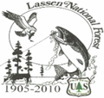
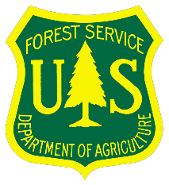
USDA Forest Service Pacific Southwest Region
LASSEN NATIONAL FOREST
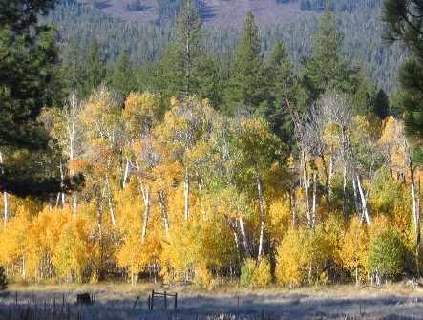 | 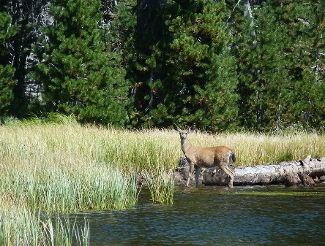 | 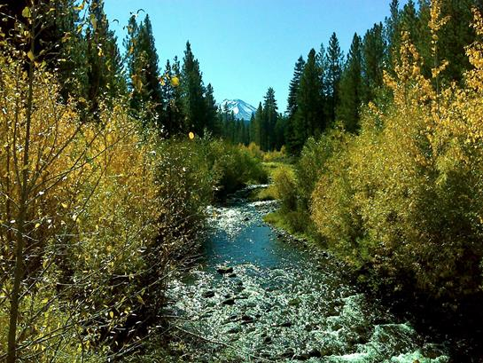
Eagle Lake District Almanor District Hat Creek District
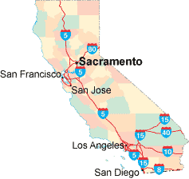
_____________________________ __
Susanville

OUTREACH NOTICE

LASSEN NATIONAL FOREST

Supervisor’s Office, Susanville, Calif.

Almanor Ranger District, Chester, Calif.
Eagle Lake Ranger District, Susanville, Calif.
Hat Creek Ranger District – Fall River Mills, Calif.
_____________________________ ______
Region 5 Pacific Southwest

Spring 2020 Centralized Temp Fire Hiring

GS-0462-3 through GS-0462-5

SUMMER 2020 TEMPORARY POSITION OUTREACH

Apply between September 16 through September 30, 2019

The Region 5 Fire Hire program has been implemented to streamline the hiring process for permanent fire positions and provide consistent hiring throughout the Region. This hiring process assists the National Forests in the Pacific Southwest Region (Region 5) to fill vacancies in an efficient and timely manner.

The unique feature of Fire Hire is the ability to immediately backfill positions that have been vacated.

Lassen Fire Program

The Lassen National Forest is looking for a committed, hardworking, highly skilled workforce to manage wildfires. The Fire and Aviation Management program, based out of Susanville, California, is comprised of the Lassen N.F. Supervisors Office and three Districts (Almanor, Hat Creek, & Eagle Lake). The Lassen works through a Service First Agreement with Cal-Fire, Eagle Lake BLM, City of Susanville FS, City of Chester FD and Lassen County Fire Departments through the SIFC Interagency Dispatch Center.

The work is very rewarding and requires talented and skilled people working safely as part of a team in a variety of specialized positions including:

- Engine modules
- Water Tenders
- Type 1 Hotshot crew (20-person)
- Wildland Fire Module (10-person Handcrew)
- Helitack Module
- Dispatch Center
- Fire Prevention Technicians
- Air Tanker Base

Regional Announcement # | TEMPORARY POSITIONS | DUTY LOCATION
20-TEMPF1-CR56-0200-5DT-RP | TEMP-GS-0462-05-Forestry Technician (Helitack) | US/CA - Chester
20-TEMPF1-CR56-0935-4DT-RP | TEMP-GS-0462-04-Forestry Technician (Fire Dispatch) | US/CA - Susanville
20-TEMPF1-CR56-0936-5DT-RP | TEMP-GS-0462-05-Forestry Technician (Fire Dispatch) | US/CA - Susanville
20-TEMPF1-CR56-2037-5DT-RP | TEMP-GS-0462-05-Forestry Technician (Hotshot/Handcrew) | US/CA - Chester
20-TEMPF1-CR56-2037-5DT-RP | TEMP-GS-0462-05-Forestry Technician (Hotshot/Handcrew) | US/CA - Hat Creek
20-TEMPF1-CR56-2037-5DT-RP | TEMP-GS-0462-05-Forestry Technician (Hotshot/Handcrew) | US/CA - Susanville
20-TEMPF1-CR56-2856-4DT-RP | TEMP-GS-0462-04-Forestry Technician (Lookout) | US/CA - Burney
20-TEMPF1-CR56-2856-4DT-RP | TEMP-GS-0462-04-Forestry Technician (Lookout) | US/CA – Paynes Creek
20-TEMPF1-CR56-2856-4DT-RP | TEMP-GS-0462-04-Forestry Technician (Lookout) | US/CA – Forest Ranch
20-TEMPF1-CR56-2856-4DT-RP | TEMP-GS-0462-04-Forestry Technician (Lookout) | US/CA - Old Station
20-TEMPF1-CR56-2856-4DT-RP | TEMP-GS-0462-04-Forestry Technician (Lookout) | US/CA - Susanville
20-TEMP1-CR56-3451-5DT-RP | TEMP-GS-0462-05-Forestry Technician (Lookout) | US/CA - Burney
20-TEMP1-CR56-3451-5DT-RP | TEMP-GS-0462-05-Forestry Technician (Lookout) | US/CA – Forest Ranch
20-TEMP1-CR56-3451-5DT-RP | TEMP-GS-0462-05-Forestry Technician (Lookout) | US/CA - Mineral
20-TEMP1-CR56-3451-5DT-RP | TEMP-GS-0462-05-Forestry Technician (Lookout) | US/CA - Old Station
20-TEMP1-CR56-3451-5DT-RP | TEMP-GS-0462-05-Forestry Technician (Lookout) | US/CA - Susanville
20-TEMPF1-CR56-3867-3DT-RP | TEMP-GS-0462-03-Forestry Aid (Fire Suppression) | US/CA - Chester
20-TEMPF1-CR56-3867-3DT-RP | TEMP-GS-0462-03-Forestry Aid (Fire Suppression) | US/CA - Fall River Mills
20-TEMPF1-CR56-3867-3DT-RP | TEMP-GS-0462-03-Forestry Aid (Fire Suppression) | US/CA - Forest Ranch
20-TEMPF1-CR56-3867-3DT-RP | TEMP-GS-0462-03-Forestry Aid (Fire Suppression) | US/CA - Hat Creek
20-TEMPF1-CR56-3867-3DT-RP | TEMP-GS-0462-03-Forestry Aid (Fire Suppression) | US/CA - Manzanita Lake
20-TEMPF1-CR56-3867-3DT-RP | TEMP-GS-0462-03-Forestry Aid (Fire Suppression) | US/CA - Mineral
20-TEMPF1-CR56-3867-3DT-RP | TEMP-GS-0462-03-Forestry Aid (Fire Suppression) | US/CA - Old Station
20-TEMPF1-CR56-3867-3DT-RP | TEMP-GS-0462-03-Forestry Aid (Fire Suppression) | US/CA - Susanville
20-TEMPF1-CR56-3868-4DT-RP | TEMP-GS-0462-04-Forestry Technician (Fire Suppression) | US/CA - Burney
20-TEMPF1-CR56-3868-4DT-RP | TEMP-GS-0462-04-Forestry Technician (Fire Suppression) | US/CA - Chester
20-TEMPF1-CR56-3868-4DT-RP | TEMP-GS-0462-04-Forestry Technician (Fire Suppression) | US/CA - Fall River Mills
20-TEMPF1-CR56-3868-4DT-RP | TEMP-GS-0462-04-Forestry Technician (Fire Suppression) | US/CA - Forest Ranch
20-TEMPF1-CR56-3868-4DT-RP | TEMP-GS-0462-04-Forestry Technician (Fire Suppression) | US/CA - Hat Creek
20-TEMPF1-CR56-3868-4DT-RP | TEMP-GS-0462-04-Forestry Technician (Fire Suppression) | US/CA - Manzanita Lake
20-TEMPF1-CR56-3868-4DT-RP | TEMP-GS-0462-04-Forestry Technician (Fire Suppression) | US/CA - Mineral
20-TEMPF1-CR56-3868-4DT-RP | TEMP-GS-0462-04-Forestry Technician (Fire Suppression) | US/CA - Old Station
20-TEMPF1-CR56-3868-4DT-RP | TEMP-GS-0462-04-Forestry Technician (Fire Suppression) | US/CA - Susanville
20-TEMPF1-CR56-3869-5DT-RP | TEMP-GS-0462-05-Forestry Technician (Fire Suppression) | US/CA - Burney
20-TEMPF1-CR56-3869-5DT-RP | TEMP-GS-0462-05-Forestry Technician (Fire Suppression) | US/CA - Chester
20-TEMPF1-CR56-3869-5DT-RP | TEMP-GS-0462-05-Forestry Technician (Fire Suppression) | US/CA - Fall River Mills
20-TEMPF1-CR56-3869-5DT-RP | TEMP-GS-0462-05-Forestry Technician (Fire Suppression) | US/CA - Forest Ranch
20-TEMPF1-CR56-3869-5DT-RP | TEMP-GS-0462-05-Forestry Technician (Fire Suppression) | US/CA - Hat Creek
20-TEMPF1-CR56-3869-5DT-RP | TEMP-GS-0462-05-Forestry Technician (Fire Suppression) | US/CA - Manzanita Lake
20-TEMPF1-CR56-3869-5DT-RP | TEMP-GS-0462-05-Forestry Technician (Fire Suppression) | US/CA - Mineral
20-TEMPF1-CR56-3869-5DT-RP | TEMP-GS-0462-05-Forestry Technician (Fire Suppression) | US/CA - Old Station
20-TEMPF1-CR56-3869-5DT-RP | TEMP-GS-0462-05-Forestry Technician (Fire Suppression) | US/CA - Susanville
20-TEMPF1-R5-3951-5DT-PM | TEMP-GS-0462-05-Forestry Technician (Airtanker Base) | US/CA - Chester

The Lassen Forest and District FMOs are listed below; duty stations are highlighted in red.
Name | Email | Title | Phone | Area of responsibility and  duty station
Larry Pingel | larry.pingel@usda.gov | Acting Forest FMO Chief 1 | (530) 252-6630 | Lassen Supervisor’s Office (Susanville)
Dustan Mueller | dmueller@fs.fed.us | Deputy FMO Chief 2 | (530) 252-6621 | Lassen Supervisor’s Office  (Susanville)
Debbie Mayer | dmayer@fs.fed.us | Division 3 | (530) 336-5521 ext. 3300 | Hat Creek Ranger District  Division Chief (FMO)  (Fall River Mills, Old Station, Hat Creek)
Adam Leyba | adam.leyba@usda.gov | Acting Division 8 | (530) 257-4188 | Eagle Lake Ranger District  (Susanville)
Nick Bunch | nbunch@fs.fed.us | Acting Division 1 | (530) 258-2141 | Almanor Ranger District  (Chester, Forest Ranch, Mineral)
Brian Rogers | bjrogers@fs.fed.us | Division Chief 2 | (530) 258-5106 | Lassen NF Aviation  Division Chief  (Susanville/Chester)

Forest Service Outreach & Employment Database: We encourage you to research upcoming job opportunities through the new US Forest Service Employment and Outreach Website. Interested applicants are encouraged to set up a personal profile @ https://hrm.gdcii.com/outreach/. The database allows you to search for upcoming jobs and provides you with the choice to be notified when positions you express interest in are posted on the USAJOBs website and open for you to apply. Remember: If you respond to the outreach through a module or on the US Forest Service Employment and Outreach Website, you still must apply through www.usajobs.gov once positions are advertised.

Dates to remember!

Vacancy Opening and Closing Date: September 16 / September 30, 2019

Applicants must complete the application process and submit all required documents electronically by 11:59 p.m. Eastern Time (ET), September 30, 2019, for any announcement applicable to PSW Fire Hire.

How to Apply

Please use the announcement numbers starting with 20-TEMP1 when searching. If applying to the merit vacancy announcement, Applicants will need to perform the following steps to retrieve the announcement:

- Go to https://www.usajobs.gov.
- Enter the merit vacancy announcement number into the entry field located mid-page entitled: “Keyword”
- Click “Search” button after entering location of choice.
- Located within the box to the left entitled: “Who May Apply” click on the circle to the left of “Federal Employees”. This will cause the merit vacancy announcement to appear in the list of results.

Individuals interested in applying to positions under Fire Hire will be utilizing eRecruit through USAJOBS. Forest Service employees applying to any Regional announcement must have a USAJOBS profile created before applying for a position in eRecruit. Information entered into the USAJOBS profile will carry over to eRecruit and avoid duplicate data entry. Additional information on eRecruit or USAJOBS can be found by going to http://fsweb.asc.fs.fed.us/hrm/erecruit/ and www.usajobs.gov.

Positions are identified as Interagency Fire Program Management (IFPM) and Forest Service Fire Program Management (FS-FPM), which are subject to IFPM Selective Placement Factors or FS-FPM Minimum Qualification Standards. These requirements are made up of primary core, secondary core and additional required training as outlined in the US Forest Service Standard Position Description Crosswalk. The following website can be referenced for additional information: http://www.fs.fed.us/fire/management/ifpm/crosswalk.pdf

- Applicants applying to positions requiring IFPM and/or FS-FPM must submit a recent copy of their Incident Qualification and Certification System (IQCS) or (IQS) Master Record or equivalent documentation that contains documented 3rd party proof of the NWCG Qualification or Additional Required Training requirement. If the IQCS or IQS Master Record cannot be obtained (or is not used in the case of private sector), the applicant must submit documentation that shows the applicant has attained the required NWCG Qualifications and Training. Submitted documentation must include 3rd party certification (e.g., signature of the certifying official’s name, title, contact information, and date of certification). Proof of NWCG qualification includes documentation such as:

  - Copy of Position Task Book (PTB) certification page (page 2 only of the PTB) that has been signed and dated by the applicant’s certifying official or,

  - Screen capture from the IQCS or IQS database showing certification of the required NWCG qualification (i.e., ”Incident Qualification Card” tab, “Competency Evaluation” tab, “Qual Card Summary” tab, or “Current Competencies” tab, etc.) AND,

Proof of required NWCG training (if applicable), such as:

  - Copy of the required training certificate that is signed and dated by the Lead Instructor or Course Coordinator or,

  - Copy of the course completion letter that is signed and dated by the course coordinator that shows successful completion of the NWCG course or,

  - Screen capture from IQCS database or IQS showing attainment of the required training (i.e., “Student Training Summary” tab, “Competency Evaluation” tab, “Responder Training” tab, “Current Competencies” tab, etc.).

Applicants with expired NWCG qualifications are still eligible to apply; however, they must attach the above documentation that proves that at one time they were certified in the required NWCG qualification(s) (i.e., expired qualification due to expiration of Work Capacity Test (WCT) or refresher, or expired due to lack of position performance currency).

FAILURE to provide the requisite documentation could result in disqualification.

Applicants must complete the application process and submit all required documents electronically by 11:59 p.m. Eastern Time (ET), September 30, 2019, for any announcement applicable to Pacific Southwest Fire Hire.

Read the ENTIRE Announcement and all the Instructions before you begin.

Step1 – Create a USAJOBS account (if you do not already have one) at www.usajobs.gov. It is recommended that as part of your profile you set up automatic email notification to be informed when the status of your application changes. If you choose not to set up this automatic notification, then you will have to log into your USAJOBS account to check on the status of your application.

Step 2 - Create a Resume with USAJOBS (Resume Builder) or upload a Resume into your USAJOBS account. You may want to customize your resume to ensure it documents duties and accomplishments you have gained that are directly related to this position in order to verify that qualifications are met. In addition, your resume must support your responses to the online questionnaire (you may preview the online questionnaire by clicking on the link at the end of the How You Will Be Evaluated section of the job announcement). Be sure to list Supervisor’s (most current first), and references.

Step 3 - Click "Apply Online" and follow the prompts to complete the Occupational Questionnaire and attach any and all additional documents that may be required.

You can update your application or documents anytime while the announcement is open. Simply log into your USAJOBS account and click on "Application Status." Click on the position title, and then select "Update Application” to continue.

Any edits, changes, or additional attachments done after September 30th will not appear in your printed application for Region 5 Fire Hire.

REQUIRED DOCUMENTS:

The following documents must be submitted to constitute a complete application package. It is your responsibility to ensure that all required documents are received within the required timeframes. Our office cannot be responsible for incompatible software, illegible fax transmissions, delays in the mail service etc. Failure to submit required, legible documents will result in elimination from consideration.

1. Resume that includes the following information: 1) job information for which you are applying; 2) personal information; 3) education; 4) work experience; and, 5) other qualifications

2. IQCS Master Record – This is a mandatory document if you are a current or former permanent Federal employee applying to the vacancy announcement number that ends with a G (merit). If you are not a current or former permanent Federal employee and are applying to the vacancy announcement number that ends with DP (demo), you must attach all documentation to verify your qualifications for each position you are applying for.

3. College Transcripts if education is required for meeting basic qualifications and/or you are substituting education for specialized experience. An unofficial copy is sufficient with the application; however, if selected, an official college transcript will be required.

4. SF-50 Notification of Personnel Action if you are a current or former Federal employee that will verify your federal status, position title, series and grade. FSA County employees must provide the most recent Notification of Personnel Action (Form SF-50-B or FSA-50) that verifies permanent status. Also provide the SF-50 that reflects the highest grade level held on a permanent basis or the full performance level of your current position, whichever is higher.

5. Annual Performance Appraisal if you are a current Federal employee. Submit the most recently completed annual performance appraisal (dated within 18 months) which identifies the employee's official rating of record, signed by the supervisor, or a statement advising why the performance appraisal is unavailable. Do not submit a performance plan.

6. DD-214 (Member 4 Copy) and/or SF-15 Application for 10-point Veteran Preference if claiming Veterans’ Preference or eligibility for appointment under the VRA, VEOA, or 30% Disabled Veterans hiring authority.

7. Certification of Disability if you are eligible for appointment based on a disability under the Schedule a hiring authority. This certification can be documented by a counselor from a State Vocational Rehabilitation Agency or the Vocational Rehabilitation and Employment Service of the Department of Veterans Affairs; by a statement or letter on a physician/medical professionals’ letterhead stationary; or by statements, records, or letters from a Federal Government agency that issues or provides disability benefits. The certification must verify the applicant has a severe disability, is eligible under a Schedule A appointment authority, and he or she is able to perform the essential duties of the position. The certification must also describe any needed reasonable accommodation. You can review additional information at: https://www.opm.gov/disability/appempl.asp.

8. If you are eligible for appointment based on service in the Peace Corps, Vista, Action Cooperative, or another special authority, submit proof of eligibility.

9. CTAP/ICTAP documentation if separated from Federal service or pending separation based on a reduction in force (RIF) or other management workforce reduction action. Proof of eligibility must include a separation notice or Certificate of Expected Separation, SF-50 that documents the RIF separation action or most recent SF-50 (that is not an award), and latest performance appraisal (dated within the last 18 months) or a statement advising why one is unavailable.

AGENCY CONTACT INFO:

HRM Contact Center –
Albuquerque Service Center
Albuquerque NM
Phone: 877-372-7248 Option 2
Fax: 866-338-3718
TDD: 800-877-8339
Email: fsjobs@fs.fed.us

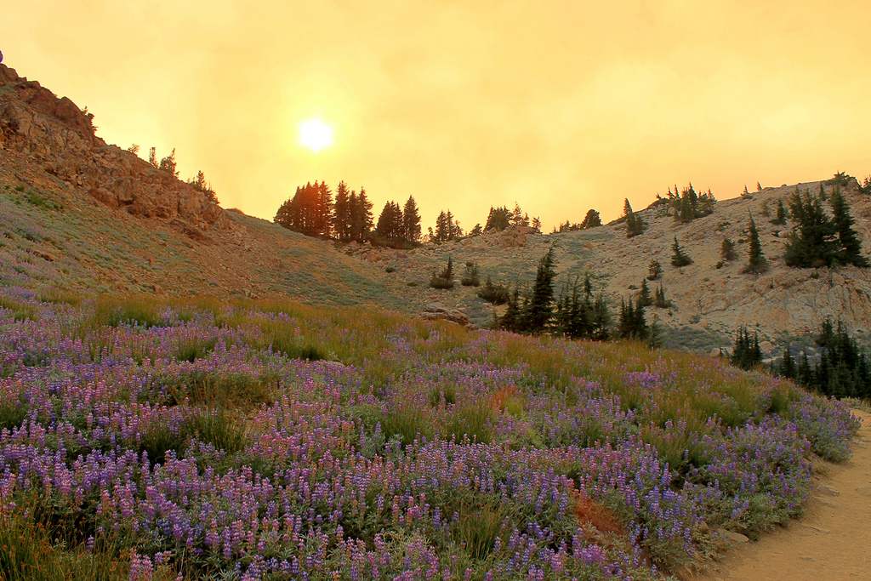
About Lassen National Forest:
Lassen National Forest lies at the crossroads of Northern California, where the granite of the Sierra Nevada, the lava of the Cascades and the Modoc Plateau, and the sagebrush of the Great Basin meet. This 1.2 million-acre forest is managed for recreational access as well as timber and firewood, forage for livestock, water, minerals, and other natural resources. The Lassen offers opportunities for hiking, camping, boating, fishing, hunting, cross-country skiing, cycling, and snowmobiling to year-round residents and visitors. For more information, visit: www.fs.usda.gov/lassen.

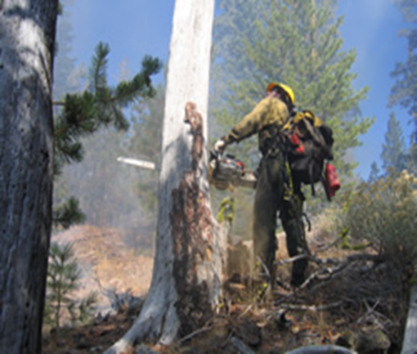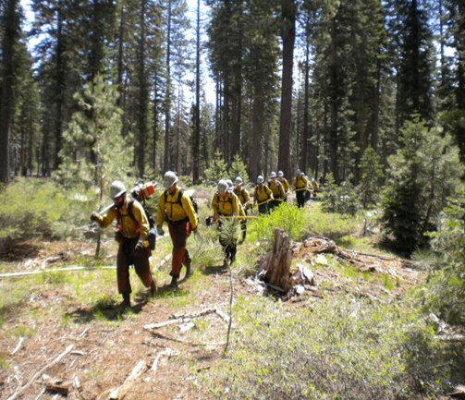

About the area:
Supervisor’s Office, Susanville, Calif.
With a population of 17,000, Susanville is the seat of Lassen County and the largest community in northeastern California. This quiet mountain community offers a hospital, a local community college, several independent school districts, churches representing most denominations, and a strong sense of community. The city of Reno, Nevada is 80 miles to the south, and the cities of Chico and Redding, California are about 100 miles to the west. At just over 4,000 feet above sea level, Susanville is surrounded by mountains and enjoys four seasons including cold winters and warm, dry summers. The community offers easy access to the lakes and mountains, as well as the numerous recreational opportunities available at the Lassen and Plumas National Forests and the Lassen Volcanic National Park.

For more information about the area, visit:
Lassen County Chamber of Commerce
City of Susanville, Calif.
Sperling’s Best Places – Susanville, Calif.
- Almanor Ranger District, Chester, Calif.
The Almanor Ranger District office is located in Chester, less than one mile from the shores of Lake Almanor and approximately 70 and 90 miles from the cities of Chico and Redding, respectively. The district includes the Ishi and Caribou Wilderness areas along with a large portion of the Lassen National Scenic Byway. With 52 miles of shoreline and views of nearby Mount Lassen, Lake Almanor has been a popular summer hiking, hunting, fishing, and boating destination for decades. In the winter, the district offers several areas for snowmobiling as well as cross-country and downhill skiing. Chester, a picturesque mountain community with a year-round population of 2,000-plus, derives a significant portion of its economy from the tourist trade. The town features shops and restaurants that cater to both residents and visitors as well as inns, hotels, campgrounds, and rental homes. The area is also a launching point to the many additional recreational opportunities available not only on Lassen National Forest, but also Plumas National Forest and the Lassen Volcanic National Park.
For more information about the area, visit:
Lake Almanor Chamber of Commerce
Sperling’s Best Places – Chester, Calif.

- Eagle Lake Ranger District, Susanville, Calif.
Surrounded by trees yet right off State Highway 36, the Eagle Lake District office is 14 miles from Eagle Lake and just four miles from downtown Susanville. The area offers many opportunities for hunting and fishing, as well as numerous trails for hiking, cycling, and horseback riding. With a population of 17,000, Susanville is the seat of Lassen County and the largest community in northeastern California. Susanville offers a hospital, a local community college, several independent school districts, churches representing most denominations, and a strong sense of community. The city of Reno, Nevada is 80 miles to the south, and the cities of Chico and Redding, California are about 100 miles to the west. At just over 4,000 feet above sea level, Susanville is surrounded by mountains and enjoys four seasons including cold winters and warm, dry summers. The community offers easy access to the lakes and mountains, as well as the numerous recreational opportunities available at the Lassen and Plumas National Forests and the Lassen Volcanic National Park.
For more information about the area, visit:
Lassen County Chamber of Commerce
City of Susanville, Calif.
Sperling’s Best Places – Susanville, Calif.

- Hat Creek Ranger District, Fall River, Calif.
Hat Creek is renowned for its trophy trout fishing, dramatic mountain vistas, scenic hiking trails, and Subway Cave – a half-mile underground tube formed by volcanic activity. The Hat Creek Ranger District office, the main point of access to this beautiful and remote region, is 14 miles from the community of Burney (population 3,000) and 70 miles from the City of Redding. Parts of the film “Stand by Me” were filmed in the area. Hat Creek is also close to many recreational opportunities available not only on Lassen National Forest, but also Modoc and Shasta-Trinity National Forests and the Lassen Volcanic National Park.

For more information about the area, visit:
Burney Chamber of Commerce
Sperling’s Best Places – Fall River Mills, Calif.
Sperling’s Best Places – Burney, Calif.

Non-discrimination Statement

In accordance with Federal civil rights law and U.S. Department of Agriculture (USDA) civil rights regulations and policies, the USDA, its Agencies, offices, and employees, and institutions participating in or administering USDA programs are prohibited from discriminating based on race, color, national origin, religion, sex, gender identity (including gender expression), sexual orientation, disability, age, marital status, family/parental status, income derived from a public assistance program, political beliefs, or reprisal or retaliation for prior civil rights activity, in any program or activity conducted or funded by USDA (not all bases apply to all programs). Remedies and complaint filing deadlines vary by program or incident.

Persons with disabilities who require alternative means of communication for program information (e.g., Braille, large print, audiotape, American Sign Language, etc.) should contact the responsible Agency or USDA’s TARGET Center at (202) 720-2600 (voice and TTY) or contact USDA through the Federal Relay Service at (800) 877-8339.

To file a program discrimination complaint, complete the USDA Program Discrimination Complaint Form, AD-3027, found online at http://www.ascr.usda.gov/complaint_filing_cust.html and at any USDA office or write a letter addressed to USDA and provide in the letter all of the information requested in the form. To request a copy of the complaint form, call (866) 632-9992. Submit your completed form or letter to USDA by: (1) mail: U.S. Department of Agriculture, Office of the Assistant Secretary for Civil Rights, 1400 Independence Avenue, SW, Washington, D.C. 20250-9410; (2) fax: (202) 690-7442; or (3) email: program.intake@usda.gov .

USDA is an equal opportunity provider, employer, and lender.

